Emergency Preparedness:
Incident Command System in HealthCare

State logo added here. If not, delete text box

Emergency Preparedness Toolkit
Incident Command System in Health Care

Incident Command System in HealthCare
The Incident Command System (ICS) was developed in the 1970s by an interagency task force working in a cooperative local, state, and federal effort called FIRESCOPE (Firefighting Resources of California Organized for Potential Emergencies) to combat wildland fires. Prior to the development of ICS, research into response to major incidents revealed weaknesses in a number of areas:
- Inadequate communication because of conflicting terminology or inefficient or improper use of technology
- Lack of a standardized management structure that would allow integration, command and control, and workload efficiency
- Lack of personnel accountability
- Lack of a systematic planning process
As a result of these and other failures, incidents of all sizes and types were often mismanaged, resulting in health and safety risks, unnecessary damage, ineffective resource management, and economic losses.
ICS is designed to meet these challenges by:
- Being effectual in managing all emergency, routine, or planned events, of any size or type, and by establishing a clear chain of command
- Allowing personnel from different agencies or departments to be integrated into a common structure that can effectively address issues and delegate responsibilities
- Provide needed logistical and administrative support to operational personnel
- Ensure key functions are covered and eliminate duplication
Fundamental Features of ICS
- Common terminology/clear text
The use of common terminology provides for a clear message and sharing of information. It avoids the use of codes, slang, or discipline‐ specific nomenclature that may not be clearly understood by all planning and response partners. A common terminology helps to define the common organizational structure: as an example, the identification of sections, section chiefs, and branch directors. Another key benefit of common terminology is the ability to share resources in the response, such as personnel to oversee incident management or operations. By using consistent terminology, the opportunity to develop memorandums or agreements to share personnel is enhanced.

- Modular organization
The ICS structure begins from the top and expands as needed by the event. Positions within the structure are activated as dictated by the incident size or complexity. As complexity increases, the ICS organization expands. Only those functions or positions necessary for an incident are activated. This will be clearly demonstrated in subsequent sections that detail the incident management team along with their roles and responsibilities.

- Management by objectives
The Incident Commander initiates the response and sets the overall command and control objectives. The mission of the response is defined for all members of the response team through a clear understanding of the organization’s policy and direction. This includes an assessment of the incident from the current situation to projected impacts. To meet the overall mission, or command objectives, individual sections will establish incident objectives as well as the strategies to achieve these objectives through clear tactics. Because emergency response is not “business as usual,” clearly defined objectives will allow staff to focus on the roles in the response, avoiding duplication of efforts or omission of critical actions.

- Incident Action Planning
The development of objectives is documented in the Incident Action Plan (IAP). A written plan provides personnel with direction for taking actions based on the objectives identified in the IAP and reflects the overall strategy for incident management while providing measurable strategic operations for the operational period. To ease this process, ICS forms are designed and developed for nursing homes and are contained within the NHICS guidebook.

- Manageable span of control
A key concept in ICS is maintaining a span of control that is both effective and manageable. Because emergency events are not business as usual situations, the span of control for operations that are not routine should be kept at an effective number. Within ICS, the optimum span of control is one supervisor to five reporting personnel. If the number falls outside these ratios, the incident management team should be expanded or consolidated.

- Pre‐designated incident locations/facilities
In the planning stages, planners should determine the location of their response and coordination sites, including the coordination and command sites. Within ICS, sites are identified for both scene and regional coordination, such as helicopter landing zones, staging areas, command posts, and emergency operations centers. Planners within the nursing home or long‐term care facility should identify sites for ICS management, staging areas for receipt of supplies and equipment, evacuation sites if the infrastructure is unsafe, and so on.

- Resource management
Resources used in the response are categorized as tactical and support. Tactical resources include personnel and major equipment available or potentially available for use in the response. Support resources are all other resources to support the incident, including food, equipment, communications, supplies, vehicles, etc. It is critical in the response to understand the availability and status of both tactical and support resources. It is important to have a clear picture of current and needed resources when working within the medical mutual aid system in the jurisdiction of state, allowing those providing the response support to provide the necessary assets through a clear understanding of current capability.

- Integrated communications
There are three elements within integrated communications: modes, plans and networks. The modes include the hardware systems that transfer information, such as radios, cell phones, and pagers. Plans should be developed in advance on how to best use the available modes through a clear and concise communication policy and plans (for example, determining who can use radios and what information should be communicated). The networks identified within the jurisdiction will determine the procedures and processes for transferring information internally and externally.

- Common command structure
The ICS provides for a common command structure that identifies core principles for an efficient chain of command. Unity of Command dictates that each person within the response structure reports to only one supervisor. A single command exists when a single agency or discipline responds to an event; for example, the fire service at a warehouse fire is commanded by a fire captain or chief. When multiple agencies or disciplines are working together at a scene, there is a unified command structure that allows for coordination in response actions. For nursing homes, this may occur when the facility is the scene of the incident, such as a fire. The nursing home administration and the fire command work together in a unified command structure.

Incident Management Functions
It is important to understand that ICS is a management system and not an organizational chart. It is predicated on a number of principal tenets:
- Every incident or event requires that certain management functions be performed. The problem encountered is evaluated, a plan to remedy the problem is identified and implemented, and the necessary resources assigned. Management by Objectives (MBO) is thus a critically important component to the successful implementation of an incident command system and involves the inclusion of both control and operational period objectives.
- The ICS organization frequently does not correlate to the daily administrative structure of the agency or nursing home. This practice is purposeful and done to reduce role and title confusion. Those positions activated in the response come together to serve as the Incident Management Team (IMT), whose purpose is to respond to and recover from the event through coordinated objectives and tactics.
- Position titles within the IMT should remain unchanged; this promotes interoperability between response partners, allowing for sharing of personnel resources among organizations.
- The IMT structure consists of the command, general, branch and unit staff, with sections clearly identified by the roles and responsibilities they carry out.
  - Incident Commander is the only position always activated in an incident regardless of its nature. In addition to Command, which sets the objectives, devises strategies and priorities, and maintains overall responsibility for managing the incident, there are four other management functions.
  - Operations conducts the tactical operations (e.g., resident services, clean‐up) to carry out the plan using defined objectives and directing all needed resources.
  - Planning collects and evaluates information for decision support, maintains resource status information, prepares documents such as the Incident Action Plan, and maintains documentation for incident reports.
  - Logistics provides support, resources, and other essential services to meet the operational objectives set by Incident Commander.
  - Finance monitors costs related to the incident while providing accounting, procurement, time recording, and cost analyses.
On small‐scale incidents, the Incident Commander may be able to accomplish all five management functions alone, but on larger incidents effective management may require that the Incident Commander establish one or more of the four other functions and appoint Section Chiefs.

Building the Incident Management Team (IMT)
The development of the IMT is based on the essential elements of ICS. The system is scalable and flexible, and uses a modular organization to respond to the event. As previously stated, the Incident Commander is the only position that is always activated. Activating additional positions is considered when the event duration increases, when situational information provides insight on the possible impact to the facility and when the span of control is exceeded.

Management tools have been developed to help determine the need for activating additional positions; these tools (Job Action Sheets, Forms, and Incident Response Guides) should be customized by individual facilities based on their staffing and possible response actions.
Position titles within the IMT define the role and the tasks assigned to that role. Titles identify the hierarchy within the chain of command. These titles include:
- Commander: there is only one commander position during the incident response, this being the Incident Commander.
- Officers: officers are part of the command section. In NHICS, the officer roles are the Liaison Officer, Public Information Officer, Medical Director/Specialist and Safety Officer. Each of these positions report directly to the Incident Commander.
- Chiefs: oversight for the section is provided by a Section Chief.
- Directors: branches may be activated under the sections to maintain the chain of command and provide specific duties and actions as identified by the position title. For example, within the Operations Section, there is a Resident Services Branch and an Infrastructure Branch, with oversight provided by Directors. ‐
- Leaders: units may be activated within a branch when there is a specialized but complex set of duties that relate to a specific assignment. The person assuming responsibility for a Unit is a Leader.
The NHICS incident management team chart illustrates how authority and responsibility is laid out during an activation of the emergency plan. In traditional Incident Command, there are five sections: Command, Operations, Planning, Logistics, and Finance. The Incident Commander Position is the only one that is always activated in an emergency and in small scale incidents, the Incident Commander may be able to accomplish all five management functions without the activation of additional positions. For large incidents, additional positions may be activated, with the overall goal to maintain the span of control and meet the needs of the facility based on the available resources. An important feature of the incident command system is its scalability. NHICS positions are assigned to personnel as indicated by the situation, and may be activated or deactivated as the incident unfolds and the needs change or become more clearly defined.

Within the Incident Management Team chart, positions are demonstrated for optimal staffing. When positions cannot be activated due to staffing, the roles and responsibilities are rolled into the highest position activated. For example, if the position of Liaison Officer cannot be activated, the tasks for that position become the responsibility of the Incident Commander.

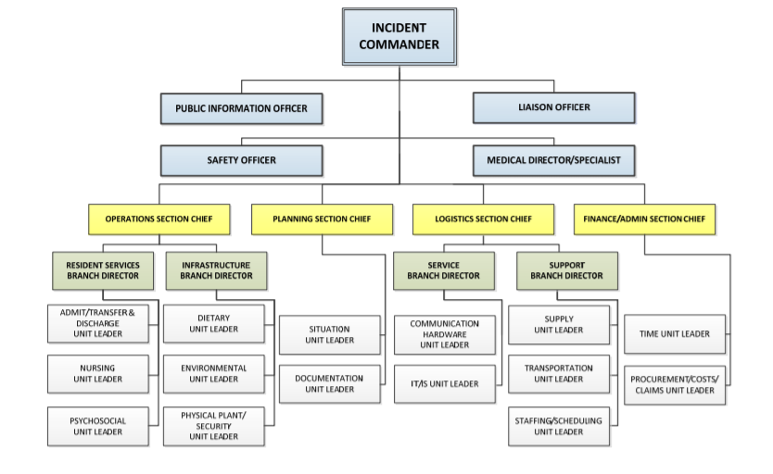
NHICS Incident Management Team: Command
The Incident Commander is the only position that is always activated. The Incident Commander activates and directs the response through the development of command objectives to direct the response. In many cases, the Incident Commander may be the only position that is activated. A critical responsibility of the Incident Commander is the decision to evacuate the facility. Based on the incident hazard that causes evacuation, this can be a difficult decision and is based on overall situational information, the projected impact, the threat to life and property, and the capability for safe evacuation.

The Safety Officer within the Command Staff is responsible for overall safety of the response actions, modifying or suspending operations if the conditions are unsafe to continue. For example, a nursing home may be forced to evacuate all or part of the facility due to an earthquake. The Safety Officer should evaluate the site where residents are moved to, ensuring that this location is free of hazards.

The Liaison Officer serves as the link for the nursing home with external partners. This position provides information to external response agencies such as public health authorities, emergency management officials, and other agencies as identified by the facility during planning and response.

The Medical Director/Specialist is the person with specific expertise in clinical areas such as infectious disease, trauma management, and medical ethics who may be asked to provide the Incident Command staff with needed advice and coordination assistance. This role may be filled by persons outside of the facility but ideally will be filled by the facility’s Medical Director/Specialist who has familiarity with the resident population, and the disaster plan for the facility. In the IMT illustrated above, the Medical Director/Specialist reports to the Incident Commander; however, in actual event, this specialist may work directly with operations personnel providing advice or guidance in the response activities.

NHICS Incident Management Team: Operations
Many incidents that occur involve altered conditions of care for the residents. There could be environmental changes such as loss of power and/or poor air quality that will require emergency measures to protect residents from harm. There also could be injured or ill residents and staff who will require first aid and/or an environment that needs immediate cleaning or repair. These critical actions become the responsibility of the Operations Section who will be responsible for managing the tactical objectives outlined by the Incident Commander.

The Operations Section is considered the “doers” and consists of nine positions. Oversight of the Section is by a Chief. Additional positions include a Resident Services Branch Director, and an Infrastructure Branch Director. Under these two branches, the unit positions of Nursing, Psychosocial, Admit/Transfer & Discharge, Dietary, Environmental, and Physical Plant/Security may be activated depending on the situation.

The Operations Section Chief oversees all tactical operations carried out within the response. He/she will activate the additional positions based on the needs of the event, as well as the availability of qualified personnel to fill the positions. Remember that if a position is needed but there is insufficient staffing to fill that position, the functions of that position are assumed by the highest position activated in that section.

The Resident Services Branch Director is responsible for the continuation of resident services as well as the provision of care to residents, staff and visitors who are injured or become ill due to the incident. The Resident Services Branch Director may assign staff to ensure continuation of resident services, including rehabilitation and vocational services as provided by the facility. The Resident Services Branch Director must also ensure that residents are accounted for and tracked, and that services needed to sustain operations are identified and provided.

The Infrastructure Branch Director is responsible for the continuation of those services that support the care in the facility including dietary, housekeeping, power, lighting, water, sewage, and other essential services. The Infrastructure Branch Director may also be required to assess the structural soundness of the facility in the event of an assault on the building such as from an earthquake, tornado, or fire, and then advise the Operations Section Chief on the capacity of the structure to sustain occupancy.

The Physical Plant/Security Unit Leader under the Infrastructure Branch is responsible for ensuring that the nursing home and the surrounding grounds are secure during the response. This may include traffic control as well as lock‐ down of the facility due to security threats, structural damage or infectious disease outbreaks. Planning should address the use of facility personnel to perform this role but also the integration of local law enforcement and/or private security firms if needed.

Within these established positions in the IMT, staff in day‐to‐day positions may continue their tasks and actions, reporting their status to the applicable branches. For example: the facility housekeeper(s) may report observed damages after an earthquake to the Infrastructure Branch Director. Those personnel who provide resident services, such as physical or occupational therapy, may report their status to the Resident Services Branch Director.
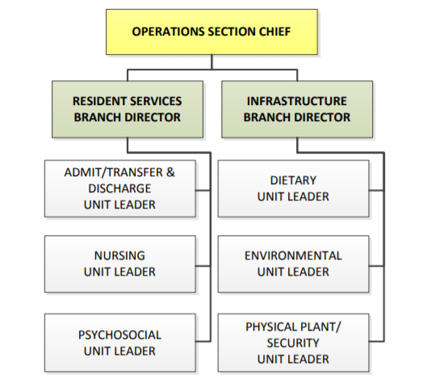

NHICS Incident Management Team: Logistics
The Logistics Section is considered the “getters” for the response. Logistics provides the necessary services and support to sustain operations during the emergency response. This section identifies and inventories current resources including supplies, equipment, and personnel, and obtains those additional items needed to support operations.

The Logistics Section Chief oversees the provision of services and support to sustain current operations and the operational response to the incident. It consists of eight positions including the Chief, the Service and Support Branch Directors, and the Communication/Hardware, IT/IS, Supply, Staffing/Scheduling, and Transportation Units. This section’s responsibilities include personnel/manpower, supplies, equipment, pharmaceuticals, and vehicles. The Logistics Section works closely with the Operations Section, responding to supply requests and their acquisition based on the needs of the response. During pre‐event planning, a staging area (or areas) should be established and identified in the Emergency Operations Plan (EOP). The staging area will be a central location, large enough to allow for the collection of personnel, vehicles, and equipment/supplies needed in the response. The Logistics Section Chief, with the assistance of the Support Branch Director provides oversight and direction at the staging area(s), maintaining an inventory of those supplies.

There are two branches within the Logistics Section: Service and Support.
- The Service Branch will ensure the preservation of those essential services; of communications and information technology. Under the Service Branch Director, the Communications and IT/IS Unit Leaders may be activated to assist with this function.
- The Support Branch organizes and maintains the facility’s supplies, equipment, transportation and labor pool in support of the residents, staff, and staff dependents in accordance with facility policy. The Support Branch must also account for those resources used and requested for operations. Under the Support Branch Director, the Supply, Staffing/Scheduling, and Transportation Unit Leaders may be activated to assist with this function.
Pre‐incident planning should identify critical items that may be needed for various responses based on annual completion of a Hazard Vulnerability Analysis. The on‐hand inventory documentation should be kept current and readily available for use when needed.
During a response, needed items that are not “in‐house” may be obtained from off the shelf stores or through standard ordering procedures, emergency procurement contracts, mutual aid agreements between facilities, corporate support, and/or requests to the local Emergency Operations Center – Emergency Support Function.
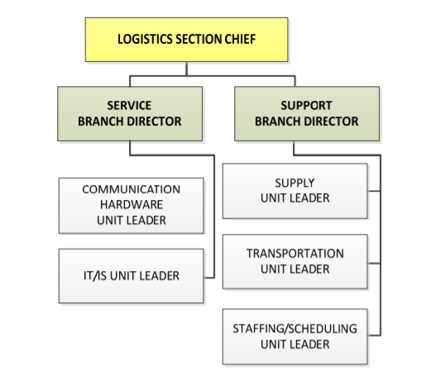

NHICS Incident Management Team: Planning
When sufficient staff are available, and when the impact of the event is sustained, the Planning Section or “thinkers” may be activated. The role of the Planning Section within the NHICS Incident Management Team is to gather and validate information from both internal and external sources. The Planning Section must also gather, analyze, and track situational response data, providing up‐to‐date and accurate information regarding residents, staff, supplies, and equipment and other resources, and projecting the ability to sustain operations based on the current and future status. This section consists of three positions.

The Planning Section Chief oversees the section and determines the need for activation of the Situation Unit and Documentation Unit. As outlined in NIMS, the Planning Section will “collect, evaluate, and disseminate incident situation information and intelligence to Incident Command.” They will also be responsible for preparing status reports, displaying various types of information, and developing the Incident Action Plan (IAP). The effectiveness of the Planning Section has a direct impact on the availability of information needed for the critical, strategic decision‐making done by the Incident Commander and the other General Staff positions.
The Situation Unit Leader will be responsible for writing and maintaining incident updates based on internal and external events, including those related to patient tracking and bed tracking. The status of supplies and equipment, both those available and in use for the response will be tracked by the Situation Unit Leader.

Multiple types of information should be documented during an incident. This information may originate from the incident scene, in one of the nursing home’s operating service areas, or from the (facility) Command Center. The Planning Section will take the lead in coordinating documentation efforts.

The role of the Documentation Unit Leader is to work with other members of the incident management team to document the incident. They also are responsible for archiving the documents created during the response. Multiple methods of documentation will likely be used during an incident. Written documentation will be the primary method of information recording. Each Incident Management Team position is tasked with maintaining their own log of issues, actions, and outcomes.
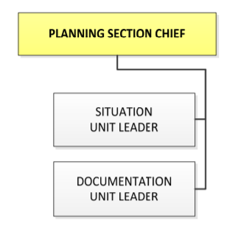
NHICS Incident Management Team: Finance/Administration
The Finance/Administration Section Chief oversees the costs and expenditures incurred by the response actions, including the purchasing of supplies and equipment. The Finance/Administration Section must also account for lost revenue associated with the response and recovery and ensure thorough investigation and documentation of incident‐related claims. Additionally, the Finance/Administration Section Chief must assist in the screening of volunteers who will be assigned to duties during the response. This section consists of three positions.
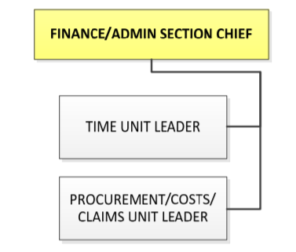
The Time Unit Leader ensures that all staff and volunteers who are utilized in the response efforts account for their hours and assists with the screening of volunteers or newly recruited staff if possible before they are assigned to any resident areas.

The Procurement/Claims/Costs Unit Leader works closely with the Logistics Section to obtain those supplies and equipment needed for the response. The costs of items procured in the response will be documented, with projections for ongoing costs that may be incurred in the response and recovery phases. The position is also responsible for coordinating all claims and compensations related to response and recovery efforts. These may include insurance and government claims related to the response as well as compensation claims related to employee, visitor, or resident injury or illness.

Position Crosswalk
To further explain the roles within the IMT, suggested nursing home positions that may fill the IMT roles have been identified. The identification of traditional nursing home positions to fill the IMT roles provides a source of discussion in the planning stage. A key step in this process is to review the roles and responsibilities of the position and to identify the most skilled person to fill the role.

The following chart is a list of suggested persons to fill the IMT roles.

Suggested Persons to fill the Incident Management Team Roles
Nursing Home Incident  Command System Position | Nursing Home Position
Incident Commander | Administrator
Medical Director/Specialist | Medical Director/Nurse Consultant
Public Information Officer | Media Relations/Administrator
Liaison Officer | Assistant Administrator
Safety Officer | Maintenance
Operations Section Chief | Director of Nursing
Resident Services Branch Director | Director of Staff Development
Nursing Unit Leader | Charge Nurse
Psychosocial Unit Leader | Social Worker/Activities Director
Admit/Transfer/Discharge Unit Leader | Charge Nurse or Rehab Director
Infrastructure Branch Director | Housekeeping Supervisor
Dietary Unit Leader | Cook
Environmental Unit | Housekeeper
Physical Plant/Security Unit Leader | Maintenance
Planning Section Chief | Assistant/Associate Administrator
Situation Unit Leader | Admissions Director
Documentation Unit Leader | Medical Records Staff
Logistics Section Chief | Assistant/Associate Administrator/Director of Dietary Services
Service Branch Director | Accounts Manager
Communication Hardware Unit Leader | Maintenance Staff/Rehab Director
IT/IS Unit Leader | Business Office Staff
Support Branch Director | Director of Social Services
Supply Unit Leader | Central Supply or Housekeeping
Staffing/Scheduling Unit Leader | Staffing Coordinator or Lead CNA
Transportation Unit Leader | Maintenance or Activity Staff
Finance/Administration Section Chief | Business/Finance Director
Time Unit Leader | Payroll/Biller
Procurement/Costs/Claims Unit Leader | Risk Manager/Quality Manager

Adapting the IMT to Large and Small Facilities
In the planning stages, nursing home administrators and managers should determine the availability of on‐site staff to fill IMT positions. This should include identification of staff on all shifts; those persons readily available to fill positions during the day may not be immediately available during the night or on weekends. The IMT chart should be kept current and accessible.

For smaller facilities or during off hours for any facility, it may be necessary for administrators/managers who are working and still on‐site to initially assume multiple roles until additional personnel arrive.

The use of NHICS and common training conducted by all of the nursing homes in a community will help to insure that these facilities can help one another, especially when the problem is isolated to one facility. Those not impacted may be able to share IMT trained personnel as well as other equipment and supplies.

Job Action Sheets
Job Action Sheets are generic forms used in all response and recovery efforts. Each Job Action Sheet (JAS) identifies the position by title followed by a mission statement that reinforces the roles and responsibilities assigned to that position.
An information box is found at the top of each JAS, allowing for documentation of the position assignment and key response information, including location and contact data.

The Job Action Sheet provides a chronological list of tasks to consider in the response. This serves not only as a response guide but also as a documentation tool. The design allows for recording what action was taken, by whom, the time, and other pertinent details

On the JAS for Command and General (Section Chiefs) staff, actions are grouped into four separate time periods:
Immediate 0‐2 hours
Intermediate 2‐12 hours
Extended Beyond 12 hours
Demobilization/System Recovery

On the JAS for Branch and Unit staff, the actions are grouped into two separate time periods:
Immediate 0‐2 Hours
On‐Going Ongoing until told to resume normal duties

The JAS also includes a list of job tools: those additional items that will facilitate the response. These may include copies of specific forms, communication tools such as radios, and response‐generated paperwork. As with other sections of the JAS, this area may be revised to include those response tools that will aid the person assigned to the position.
The Job Action Sheet should be customized to the individual nursing home. This can be done in the planning stage, allowing qualified persons who are identified to fill the positions to review the tasks, recommending changes to better explain the actions and incorporate additional tasks specific to the facility. In the after‐action phase, the Job Action Sheets should be reviewed, noting if tasks were completed, the time of completion, and any additional actions undertaken not currently on the JAS. This will allow for revision of the JAS with the resulting enhancement and customization of the guide. Job Action Sheets for all positions identified on the IMT have been developed.

A sample Incident Commander Job Action Sheet is on the following pages. Download a copy of this and other command job action sheets at http://www.emsa.ca.gov/hospital_incident_command_system_job_action_sheets_2014_Command.

SAMPLE
Mission: Organize and direct the Hospital Command Center (HCC). Give overall strategic direction for hospital incident management and support activities, including emergency response and recovery. Approve the Incident Action Plan (IAP) for each operational period.

Position Reports to: Executive Administration Command Location:
Position Contact Information: Phone: ( ) - Radio Channel:
Hospital Command Center (HCC): Phone: ( ) - Fax: ( ) -
Position Assigned to: | Date: / / | Start: ____:____ hrs.
Signature: | Initials: | End: ____:____ hrs.
Position Assigned to: | Date: / / | Start: ____:____ hrs.
Signature: | Initials: | End: ____:____ hrs.
Position Assigned to: | Date: / / | Start: ____:____ hrs.
Signature: | Initials: | End: ____:____ hrs.

Immediate Response (0 – 2 hours) | Time | Initial
Receive appointment
- Gather intelligence, information and likely impact from the sources providing event notification
- Assume the role of Incident Commander and activate the Hospital Incident Command System (HICS)
- Review this Job Action Sheet
- Put on position identification (e.g., position vest)
- Notify your usual supervisor and the Hospital Chief Executive Officer (CEO) of the incident, activation of the Hospital Command Center (HCC), and your assignment
Assess the operational situation
- Activate the Hospital Emergency Operations Plan (EOP) and applicable Incident Specific Plans or Annexes
- Brief Command Staff on objectives and issues, including:
- Size and complexity of the incident
- Expectations
- Involvement of outside agencies, stakeholders, and organizations
- The situation, incident activities, and any special concerns
- Seek feedback and further information
Determine the incident objectives, tactics, and assignments
- Determine incident objectives for the operational period
- Determine which Command Staff need to be activated:
- Safety Officer
- Liaison Officer
- Public Information Officer
- Determine the impact on affected departments and gather additional information from the Liaison Officer
- Appoint a Planning Section Chief to develop an Incident Action Plan (IAP)
- Appoint an Operations Section Chief to provide support and direction to affected areas
- Appoint a Logistics Section Chief to provide support and direction to affected areas
- Appoint a Finance Section Chief to provide support and direction to affected areas
- Determine the need for, and appropriately appoint or ensure appointment of Medical-Technical Specialists
- Make assignments and distribute corresponding Job Action Sheets and position identification
- Ensure hospital and key staff are notified of the activation of the Hospital Command Center (HCC)
- Identify the operational period and any planned Hospital Incident Management Team (HIMT) staff shift changes
- Conduct a meeting with HIMT staff to receive status reports from Section Chiefs and Command Staff to determine appropriate response and recovery levels, then set the time for the next briefing
Activities
- Ensure all activated positions are documented in the Incident Action Plan (IAP) and on status boards
- Obtain current patient census and status from the Planning Section Chief
- Determine the need to activate surge plans based on current patient status and injury projections
- If additional beds are needed, authorize a patient prioritization assessment for the purposes of designating appropriate early discharge
- If applicable, receive an initial hospital damage survey report from the Operations Section Infrastructure Branch and evaluate the need for evacuation
Documentation
- Incident Action Plan (IAP) Quick Start
- HICS 200: Consider whether to use the Incident Action plan (IAP) Cover Sheet
- HICS 201: Initiate the Incident Briefing form
- HICS 204: Assign or complete the Assignment List as appropriate
- HICS 207: Assign or complete the Hospital Incident Management Team (HIMT) Chart
for assigned positions
- HICS 213: Document all communications on a General Message Form
- HICS 214: Document all key activities, actions, and decisions in an Activity Log on a continual basis
- HICS 252: Distribute the Section Personnel Time Sheet to Command and Medical-Technical Specialist Staff and ensure time is recorded appropriately
Resources
- Assign one or more clerical personnel from current staffing or make a request for staff to the Logistics Section Chief, if activated, to function as Hospital Command Center (HCC) recorders
Communication
Hospital to complete: Insert communications technology, instructions for use and protocols for interface with external partners
Safety and security
- Ensure that appropriate safety measures and risk reduction activities are initiated
- Ensure that HICS 215A – Incident Action Plan Safety Analysis is completed and distributed
- Ensure that a hospital damage survey is completed if the incident warrants

Intermediate Response (2 – 12 hours) | Time | Initial
Activities
- Transfer the Incident Commander role, if appropriate
- Conduct a transition meeting to brief your replacement on the current situation, response actions, available resources and the role of external agencies in support of the hospital
- Address any health, medical, or safety concerns
- Address political sensitivities, when appropriate
- Instruct your replacement to complete the appropriate documentation and ensure that appropriate personnel are briefed on response issues and objectives (see HICS Forms 203, 204, 214, and 215A)
- Schedule regular briefings with Hospital Incident Management Team (HIMT) staff to identify and plan to:
- Ensure a patient tracking system is established and linked with appropriate outside agencies and the local Emergency Operations Center (EOC)
- Develop, review, and revise the Incident Action Plan (IAP), or its elements, as needed
- Approve the IAP revisions if developed by the Planning Section Chief, then ensure that the approved plan is communicated to HIMT staff
- Ensure that safety measures and risk reduction activities are ongoing and re-evaluate if necessary
- Consider deploying a Public Information Officer to the local Joint Information Center (JIC), if applicable
Documentation
- HICS 214: Document all key activities, actions, and decisions in an Activity Log on a continual basis
Resources
- Authorize resources as needed or requested by Command Staff or Section Chiefs
Communication
Hospital to complete: Insert communications technology, instructions for use and protocols for interface with external partners
Safety and security
- Ensure that patient and personnel safety measures and risk reduction actions are followed

Extended Response (greater than 12 hours) | Time | Initial
Activities
- Transfer the Incident Commander role, if appropriate
- Conduct a transition meeting to brief your replacement on the current situation, response actions, available resources and the role of external agencies in support of the hospital
- Address any health, medical, or safety concerns
- Address political sensitivities, when appropriate
- Instruct your replacement to complete the appropriate documentation and ensure that appropriate personnel are briefed on response issues and objectives (see HICS Forms 203, 204, 214, and 215A)
- Evaluate or re-evaluate the need for deploying a Public Information Officer to the local Joint Information Center (JIC) and a Liaison Officer to the local Emergency Operations Center (EOC), if applicable
- Ensure that an Incident Action Plan (IAP) is developed for each operational period, approved, and provided to Section Chiefs for operational period briefings
- With Section Chiefs, determine the recovery and reimbursement costs and ensure documentation of financial impact
- Ensure staff, patient, and media briefings are being conducted regularly
Documentation
- HICS 214: Document all key activities, actions, and decisions in an Activity Log on a continual basis
Resources
- Authorize resources as needed or requested by Command Staff and Section Chiefs
Communication
Hospital to complete: Insert communications technology, instructions for use and protocols for interface with external partners
Safety and security
- Observe all staff and volunteers for signs of stress and inappropriate behavior and report concerns to the Safety Officer and the Logistics Section Employee Health and Well-Being Unit Leader
- Provide for personnel rest periods and relief
- Ensure your physical readiness through proper nutrition, water intake, rest, and stress management techniques

Demobilization/System Recovery | Time | Initial
Activities
- Transfer the Incident Commander role, if appropriate
- Conduct a transition meeting to brief your replacement on the current situation, response actions, available resources and the role of external agencies in support of the hospital
- Address any health, medical, or safety concerns
- Address political sensitivities, when appropriate
- Instruct your replacement to complete the appropriate documentation and ensure that appropriate personnel are briefed on response issues and objectives (see HICS Forms 203, 204, 214, and 215A)
- Assess the plan developed by the Planning Section Demobilization Unit and approved by the Planning Section Chief for the gradual demobilization of the Hospital Command Center (HCC) and emergency operations according to the progression of the incident and hospital status
- Demobilize positions in the HCC and return personnel to their normal jobs as appropriate, in coordination with the Planning Section Demobilization Unit
- Brief staff, administration, and Board of Directors
- Approve notification of demobilization to the hospital staff when the incident is no longer active or can be managed using normal operations
- Participate in community and governmental meetings and other post-incident discussion and after action activities
- Ensure post-incident media briefings and hospital status updates are scheduled and conducted
- Ensure implementation of stress management activities and services for staff
- Ensure that staff debriefings are scheduled to identify accomplishments, response, and improvement issues
Documentation
- HICS 221- Demobilization Check-Out
- Ensure all Hospital Command Center (HCC) documentation is provided to the Planning Section Documentation Unit

Documents and Tools
- Incident Action Plan (IAP) Quick Start
- HICS 200 - Incident Action Plan (IAP) Cover Sheet
- HICS 201 - Incident Briefing form
- HICS 203 - Organization Assignment List
- HICS 204 - Assignment List(s)
- HICS 205A - Communications List
- HICS 207: Hospital Incident Management Team (HIMT) Chart
- HICS 213 - General Message Form
- HICS 214 - Activity Log
- HICS 215A - Incident Action Plan (IAP) Safety Analysis
- HICS 221 - Demobilization Check-Out
- HICS 252 - Section Personnel Time Sheet
- HICS 258 - Hospital Resource Directory
- Hospital Emergency Operations Plan (EOP)
- Incident Specific Plans or Annexes
- Hospital organization chart
- Hospital telephone directory
- Telephone/cell phone/satellite phone/internet/amateur radio/2-way radio for communication

