Facility Assessment:
How to Use the Toolkit

State logo added here. If not, delete text box

How to Use the Facility Assessment Toolkit

The RoP Facility Assessment Toolkit © is designed to provide practical, step-by-step guidance for organizations as they evaluate their individual facility resident population, resource availability and allocation in accordance to resident care and service needs and other required elements in developing their written facility assessment. The following depicts the steps recommended when completing the Facility Assessment:

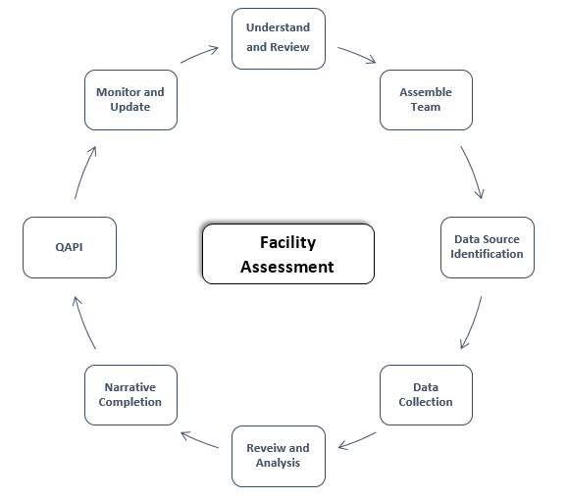

Recommended Steps – Overview

- Understand and Review the Intent of the Facility Assessment Requirements
  - Read and review the §483.70(e) Facility Assessment requirements and interpretive guidance with your team
  - Inter-related - the Facility Assessment, Quality Assurance and Performance Improvement plan and the Emergency Preparedness Plan are inter-related
  - Other requirements - The Facility Assessment is integrated into many areas of the Interpretive Guidance and will need to be appropriately addressed across departments within the facility. *See the Facility Assessment F838 Crosswalk resource tool located in the Resource Section of The RoP Facility Assessment Toolkit ©
  - Review the Facility Assessment Implementation Guide with your leadership team and determine necessary actions
  - Develop and implement a Facility Assessment Policy and Procedure (See: Facility Assessment Policy and Procedure Template)

- Assemble the Team
  - Required Team - Led by the facility administrator , the minimum team requirements include:
    - Administrator
    - Director of Nursing
    - Medical Director
    - Governing Body representative
  - Optional Team Members as applicable
    - Environmental services
    - Plant operations
    - Social services
    - Activity therapy
    - Dietary
    - Direct care staff
    - Residents or representatives
    - Resident council
    - Family Council
    - Others
  - Roles and Responsibilities
    - List the team members on the Facility Assessment Team Roster
    - Determine roles and responsibilities
    - Set completion dates
    - Set meeting dates for review and analysis
    - Determine communication strategy related to findings and questions

- Data Source Identification
  - Existing data sources – utilize existing data sources for completion of the element requirements
  - Determine data sources
    - Review elements and correlate data sources
    - See RoP Facility Assessment Toolkit © sections for recommended facility data sources

- Data Collection
  - Collect data – team members to complete their assigned sections of the facility assessment
  - Verify data – verify the accuracy of the data thorough out the evaluation process.
    - If there are gaps in data or performance, review findings with leadership and initiate the appropriate improvement plan per facility policy
  - Data sources and what to collect are recommended in each section – correlating to the requirements as well as the QIO Facility Assessment Template.
  - Summary initial findings – team members will summarize their findings by utilizing the Facility Assessment Worksheet for each section of the RoP Facility Assessment Toolkit ©

- Review and Analysis
  - Analyze - Based upon the data collected, the team should review the raw data, analyze for trends and gaps and useful facility insights. Utilize the Facility Assessment Summary Worksheet per section to help summarize the findings
  - Organize the data and trends to determine key business strategies
  - Action - Review with team to determine next steps, action steps related to gaps and needs identified, and roles and responsibilities for action step completion
  - Present Findings – review findings with facility leadership, correlate to facility operating budget, and strategic plan

- Narrative Completion
  - Collate all worksheets
  - Complete the Facility Assessment Narrative Template – draft
  - Review the draft with team
  - Prepare the final narrative Facility Assessment (See Sample Template)
  - Maintain the official copy of the Facility Assessment per policy

- Quality Assurance and Performance Improvement (QAPI)
  - Incorporate the Facility Assessment findings into the QAPI process.

- Monitor and Update
  - Annual review – complete an annual review of the Facility Assessment and corresponding processes per requirement
  - Monitor the facility assessment throughout the year via the QAPI process
  - Update and revise the Facility Assessment whenever this is or the facility plan for a change that would require a modification to any part of the assessment

How to get started - next steps – Begin using the RoP Facility Assessment Toolkit © to develop your facility assessment.

- Complete the Facility Assessment Team Roster
- Review the contents of each section of the RoP Facility Assessment Toolkit © with the assigned team member.
  - Each section includes the following:
    - Overview and intent of the specific required element
    - Data compilation worksheet
    - Recommended data sources
    - Data collection tools
    - Resources
- Complete the data collection process
- Analyze and determine resources, training, competencies, physical plant and technology needed
- Implement corresponding training
  - Specific training based upon the assessment findings
  - Overview of the facility assessment process to staff
- Complete a training program evaluation
- Complete respective policy and procedure updates
- Determine Facility Assessment review process and annual review date

The process for completing the Facility Assessment appears overwhelming, however if broken down into specific tasks as outlined in the RoP Facility Assessment Toolkit ©, leaders efficiently can work side by side with their team using the Leadership QuickTIP to stay on track.

Facility Assessment Team Roster

Required Element | Task | Team Member | Completion Date | Data Sources
Resident and Facility Population | Census and Capacity
 | Diseases and Conditions
 | Physical and Cognitive Disabilities
 | Other Pertinent Factors and Specialty Programs/Services
 | Overall Acuity
 | Staff Competencies Necessary per population
 | Ethnic, Cultural, Religious Factors including food, nutrition and activities
 | Assisted Technology
 | Individual Communication Devices
 | Physical Space – Resident Rooms, Common Areas, etc.
Personnel Resources | Staffing Analysis and Ratios
 | Competency Based Training Plan
 | Personnel Listing, Resources and Competencies
 | Nutrition Services
 | Specialized Services
 | Contractual Services and Personnel
 | Volunteers
 | Training Plan Evaluation
Physical Environment | Equipment - Medical
 | Equipment – Non Medical
 | Physical Plant – Buildings and Structures
 | Vehicles
 | Assisted Technologies
Facility and Community Risk | Hazard Vulnerability Assessment
 | Integration - Emergency Preparedness Plan
 | Corporate Compliance, Ethics, Patient Safety
Health Information Technology | Electronic Health Record, Resident software
 | Security and Exchange
 | Interruption of Services
Third Party Agreements | Day to Day Provisions
 | Emergency Provisions
 | Training and Competency
Infection Prevention | Tracking and Surveillance
 | Resident Population Considerations
Policy and Procedures | Review of department policies and procedures

Facility Assessment
Leadership QuickTIP

Step | Action | Completed
Understand and Review | - Read and review the §483.70(e) Facility Assessment requirements and interpretive guidance | ☐
 | - Review the Facility Assessment F838 Crosswalk | ☐
 | - Review the Facility Assessment Implementation Guide | ☐
 | - Develop a Facility Assessment Policy and Procedure | ☐
Assemble the Team | - Complete the Facility Assessment Team Roster | ☐
Data Source | - Determine existing and needed data sources per required Facility Assessment element | ☐
Data Collection | - Team members to collect assigned data using data collection tools | ☐
 | - Verify data | ☐
 | - Summarize initial findings on Facility Assessment Worksheets per element | ☐
Review and Analysis | - Analyze and determine trends | ☐
 | - Determine key business strategies needed and resources needed | ☐
 | - Review initial findings as a team and correlate to operating budget and strategic plan | ☐
Narrative Completion | - Complete the final narrative Facility Assessment | ☐
QAPI | - Integrate the Facility Assessment into the facility QAPI process | ☐
Monitor and Update | - Identify monitoring process with team | ☐
 | - Determine Annual review data | ☐
 | - Update and revise per requirement | ☐
 | - Update corresponding policies and procedures related to Facility Assessment requirement and evaluation findings. | ☐
This tool is developed to serve as a quick checklist for Facility Assessment completion.

